**DGMD S-14 Wearable Devices and Computer Vision**

Course Overview and Contact Information

**Course Overview**

Semester and Year: Summer 2020 Start Date: June 22, 2020

Day/Times: Monday 6:30 p.m. - 9:30 p.m. & Wednesday 6:30 p.m. - 9:30 p.m. or on Demand

Format: On campus or online

Special Instructions: IoT Sensor kit required (see instructions at the end of the document in the appendix)

**Instructor(s) Contact Information TA(s) Contact Information**

Name: Jose Luis Ramirez Herran Name: TBD

Office/ Office hours: TDB Office/Office hours: TBD

Phone: 857-285-1277 . Phone: TBD

Email: jlr682@g.harvard.edu Email: TBD

Course Description and Learning Objectives

**Course Description:**

This practical course is for students who want to evolve from consumers of data to producers of data, and mine their data to innovate or create new experiences in our big data economy. Students assemble wearable devices using industry-standard sensors, collect a continuous flow of data about their bodies and environments, and learn how to analyze/process these data streams using machine learning and artificial intelligence.  Students are encouraged to use wearable devices as building blocks to help disabled persons, develop educational games, monitor senior citizens or personal health, or create artistic experiences, which they can share.

**Learning Objectives**

By immersing themselves in this course, students will be able to:

* Assemble a wearable device that collect gesture, temperature and pressure data, etc.
* Collect, clean, and analyze their own data, and become aware of the data produced by their bodies and their environments,
* Learn the basics of practical machine learning, and signal processing applicable to their projects,
* Apply the machine learning and signal processing workflows to a real-world project,
* Design wearable devices with a purpose for society: from helping people with disabilities, to accelerating the learning of children, and creating data-driven artistic experiences.

**Assessment methods**

Hands-on work is the core of this course. There are 8 tutorials, which could easily be completed in the first 5-8 weeks. Please note that all students are expected to do and complete all the tutorials. Our tutorials have been proven (UCLA has adopted them for past 2 years)

Our tutorials have been proven to be a very effective tool to easily empower students and help them built the confidence they need to take on the challenge of executing their own class projects. The University of California Los Angeles (UCLA) has been using these tutorials for the past 4 years, and they can be found on this page: https://sites.google.com/view/ucla-stmicroelectronics-iot/home

Each tutorial will be accompanied with a quiz due the week after. This weekly quiz or demo will cover reflection questions and specific concept questions to provide us with feedback of your progress. Using a short video, you will be required to demonstrate that your system is working correctly. The pre-requisite knowledge also be covered during lecture and will be evaluated with a quiz to be announced in our website. Note that Assignment 0 is not graded but is mandatory.

Course Materials

***Course Materials***

1. **Zoom**

* Laptop computer with either Windows 10 or Mac OSX High Sierra.
* High-speed Internet connection.
* Students are required to use a webcam and headset during class. We recommend a Logitech H390 headset, but any USB headset should be adequate. It is not recommended to use a microphone that is built into a laptop.

1. **Equipment**

The following is the list of items to order for the class. **At the end of this document there is an appendix with the specific ordering details.**

1. **Sensors Kit**

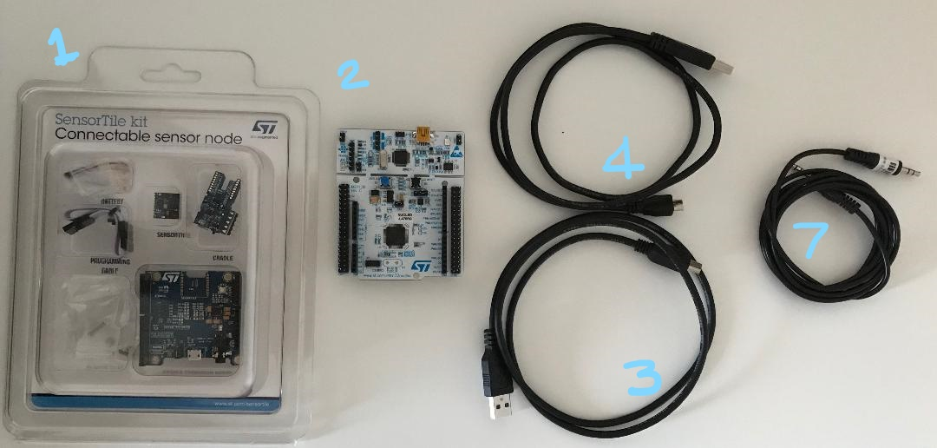

* + STMicroelectronics SensorTile x1 (Item 1 Appendix A)

1. **Testing Board**
   * STMicroelectronics Nucleo-64 Board x1 (Item 2 Appendix A)
2. **Cables**
   * USB 2.0 to Mini-B cable x1 (Item 3 Appendix A)
   * USB 2.0 to Micro USB cable x1 (Item 4 Appendix A)
   * 3.5 mm Audio Cable (Item 7 Appendix A)
3. **Accessories** (depending on your computer specifications)
   * For users of new Macbooks that do not include USB-Type A ports, then please order adapter from USB Type C to type A x2. (Item 5 Appendix A)
   * For users of any computer having only one USB Type A port, then please order a USB hub (Item 6 Appendix A)
   * For Macbooks/PCs without sound card: buy a USB Audio Adapter (Item 8 Appendix A)
4. A **Single Board Computer** with Linux OS (You need only one of your choice). See Appendix B:

**One of** the following are supported:

* Seeed Studio BeagleBone Green Wireless IoT Developer Prototyping Kit
* BeagleBone Black Wireless
* Beaglebone Black (add: 1 USB hub, 1 wireless dongle and 1 Bluetooth dongle)
* Raspberry Pi 3 Model B+
* Raspberry Pi Zero W (Wireless) or WH (Wireless with headers)

Note: You will need the following accessories:

* Power supply or a USB cable (usually USB Type A to Micro USB) to power it from your computer
* MicroSD card for booting Linux and/or to upgrade the OS. Most of these can be configured headless (avoid setting it up as desktop). **You can also buy a Starter Pack**
* **Reminder:** Because of possible compatibility issues, please consult with the instructor before buying any other sensors, capes, adapters, motors, etc. The main providers are: Mouser, Digikey, SeedStudio, Amazon, Adafruit.

Grading

***Grading***

|  |  |  |
| --- | --- | --- |
| **Description** | **Undergraduate (%)** | **Graduate (%)** |
| Sensor Tile Tutorials Homework | 50 | 40 |
| Machine Learning Homework | 20 | 20 |
| Participation (class, forums, discussions) | 20 | 20 |
| Final Projects | 10 | 20 |

**Workload:** Students expected to do at least **8–12 hours of work per week** *outside* of class time.

**Additional graduate-credit requirements:** For graduate students, the project has extra requirements and a higher percentage of the grade than the project for undergraduates and high school program students.

A Letter grade will be given in accordance with the School’s grading policy (<https://www.summer.harvard.edu/resources-policies/grades>)

Expectations and Policies

**Attendance and Assignments**

Students in “on-campus or online courses” have three options for attendance: you can attend in person; participate live online in real time; or watch the recordings of the class meetings and participate on demand, keeping up with posted deadlines for assignments and exams. Class recordings will be posted within 24 hours of the class meeting. You can choose how you’d like to attend on a day-to-day basis.

Live online participation comes in two forms. In many courses, you attend via web conference, which is broadcast on large monitors in the classroom so you can interact with the class as if you were there. In others, the class meetings are live streamed and you can communicate via text-based chat. For this course you are not required to attend live at the time the course meets.

Please see the [Course Video Technology Guidelines](https://www.extension.harvard.edu/academics/courses/types-courses/video-course-guidelines) (<https://www.extension.harvard.edu/academics/courses/types-courses/video-course-guidelines?_ga=2.157292862.549680524.1584419658-1717041902.1562607506>) for more information on accessing and viewing course videos. Please see the [Web Conference Technology Guidelines](https://www.extension.harvard.edu/academics/courses/types-courses/web-conference-technology-guidelines) (<https://www.extension.harvard.edu/academics/courses/types-courses/web-conference-technology-guidelines?_ga=2.157292862.549680524.1584419658-1717041902.1562607506>) for more information about live online participation in courses.

Homework assignments are expected to be always on time. Writing should be correct. Late assignments will get penalized with 10% of the grade per day up to 2 days. No assignment can be submitted after two days.

**Accessibility**

The Summer School is committed to providing an accessible academic community. The Accessibility Office covers a variety of accommodations and services to students with documented disabilities. More in: <https://www.summer.harvard.edu/accessibility-services>

**Important Notes for Registered Students**

We will be using a course management web service called Canvas for all course communications. Please be sure that you get a Harvard e-mail account and access to Canvas. More importantly, it is critical that you check the e-mail registered with Canvas, monitor course announcements and participate in discussions on our forum.

Please review the student responsibilities at: <https://www.summer.harvard.edu/resources-policies/student-responsibilities>

**Official Harvard Summer School Policies**

You are responsible for understanding Harvard Summer School policies on academic integrity and how to use sources responsibly (<https://www.summer.harvard.edu/resources-policies>). Not knowing the rules, misunderstanding the rules, running out of time, submitting the wrong draft, or being overwhelmed with multiple demands are not acceptable excuses. There are no excuses for failure to uphold academic integrity.

To support your learning about academic citation rules, please visit the Harvard Summer School Tips to Avoid Plagiarism (<https://www.summer.harvard.edu/resources-policies/resources-support-academic-integrity>), where you'll find links to the Harvard Guide to Using Sources (<https://www.extension.harvard.edu/resources-policies/resources/avoiding-plagiarism>) and two free online 15-minute tutorials to test your knowledge of academic citation policy. The tutorials are anonymous open-learning tools.

Please note that academic integrity issues should be handled by the Dean of Students Office. Any cases of suspected cheating or plagiarism should be brought to the attention of the Associate Dean of Students, Shirley Greene ([shirley_greene@harvard.edu](mailto:shirley_greene@harvard.edu)).

Course Outline and Schedule

**Tentative Syllabus**

Please follow our canvas site to get the updated schedule. Exact topics are subject to change!

**Tentative Weekly Topics:**

|  |  |  |  |  |
| --- | --- | --- | --- | --- |
| **Week** | **Date** | **Description** | **Assignments** | **Due Date** |
| 1 | Jun 22 | Tutorial 1. Introduction to STMicroelectronics Sensor Tile Development (Windows and MAC)  Tutorial 2. Introduction to Sensor System Signals Event Detection and Configuration |  |  |
| 1 | Jun 24 | Tutorial 3. Accelerometer Sensor Systems and Orientation and Event Detection  Tutorial 4. Introduction to Audio Sampling and Signal Processing  Tutorial 5. Firmware Programming | Homework 1 | Jun 29 |
| 2 | Jun 29 | Signal Processing and Machine Learning intro with Python |  |  |
| 2 | Jul 1 | Introduction to Linux, Single Board Computers, and Bluetooth  Tutorial 6. Introduction to Bluetooth Low Energy (BLE) Wireless Interfaces  Tutorial 7. Introduction to BLE Communication via GATT Protocol | Homework 2 | Jul 8 |
| 3 | Jul 6 | Tutorial 8. Introduction to Motion Data Acquisition via BLE Communication  Practical Machine Learning and cases  Project Proposal Methods: Analysis, Design, Ethics, Computer and Society, etc. |  |  |
| 3 | Jul 8 | BeagleBone and Raspberry Pi 3 B+ IoT Tutorials | Homework 3 | Jul 15 |
| 4 | Jul 13 | Tutorial 9. Introduction to Inertial Sensing |  |  |
| 4 | Jul 15 | Reference Design 1: Motion-Controlled Audio Signal Processing System | Homework 4 | Jul 22 |
| 5 | Jul 20 | Tutorial 10: Introduction to EmbeddedML Machine Learning |  |  |
| 5 | Jul 22 | Tutorial 11: IoT Machine Learning for Recognition of Motion Events | Homework 5 | Jul 29 |
| 6 | Jul 27 | Tutorial 12: IoT Machine Learning for Recognition of Multiple Step Motion Patterns |  |  |
| 6 | Jul 29 | Tutorial 13: IoT Machine Learning of Rotation Angle Motion Patterns by Gyroscope Sensing | Project Report | Aug 3 |
| 7 | Aug 3 | Final Project Presentations | Presentations | Aug 3 |
| 7 | Aug 5 | Final Project Presentations | Presentations | Aug 5 |

DEADLINES

* Last day to register:
  + June 18, 2020
* Last day to make course and credit status changes, and drop for 100% tuition refund:
  + June 24, 2020
* Last day to drop for 50% tuition refund:
  + July 1, 2020
* Last day to withdraw for WD grade:
  + July 24, 2020

**Appendix A: Equipment Details for Sensor Tile Development Kit**

**SensorTile Internet of Things Kit**

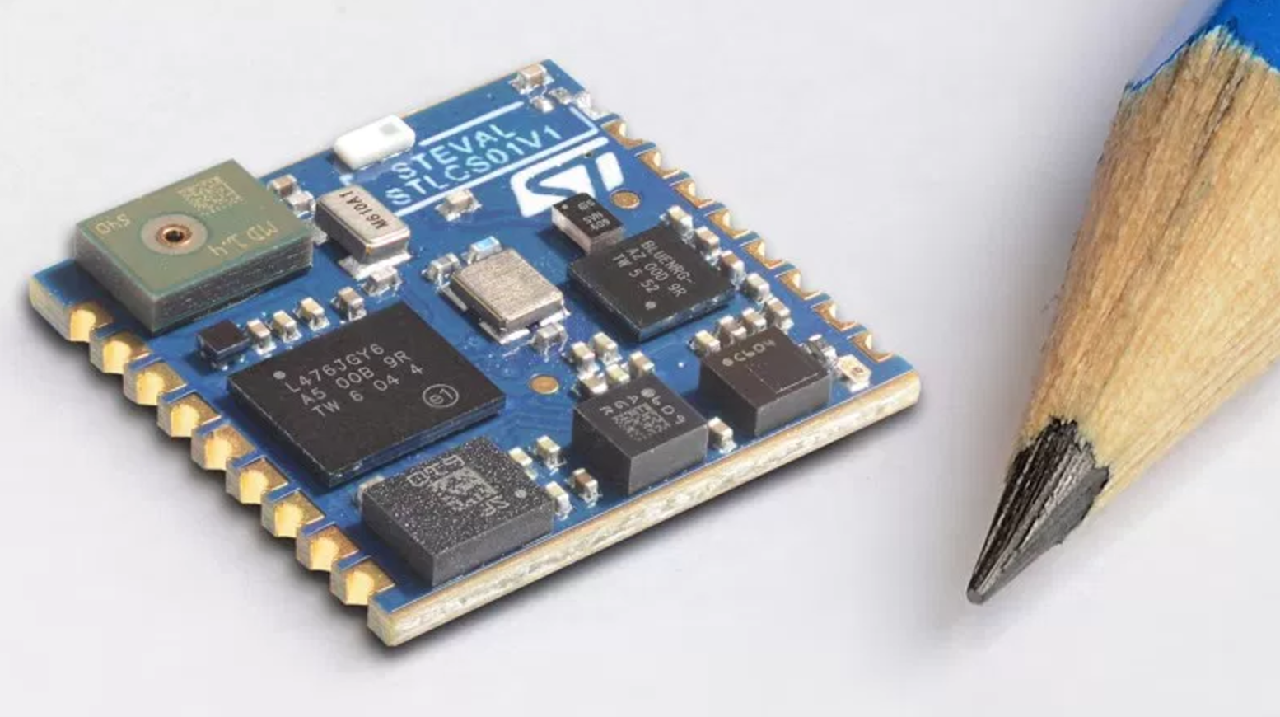

STMicroelectronics SensorTile Internet of Things System

The SensorTile Student Kit includes these components:

1. Personal Notebook computer (Apple Mac or Windows) – Please note special requirements for certain computers below.
2. Computer Power supply
3. Internet network access (via WiFi or wireline)
4. SensorTile development components below:

**Please order these items for any computer that you may be using:**

1. STMicroelectronics SensorTile (Item 1 below)
2. STMicroelectronics Nucleo-64 Board (Item 2 below)
3. USB 2.0 to Mini-B cable (Item 3 below)
4. USB 2.0 to Micro USB cable (Item 4 below)
5. For users of new Macbooks that do not include USB ports, then please order **Item 5** below.
6. For users of any computer having only one USB port, then please order **Item 6** below.

7) 3.5 mm Audio Cable

8) USB Audio Adapter   
 (in case your computer does not have one with both input/output 3.5mm sockets)

**(Item 1) STMicroelectronics SensorTile**

**Ordering Options:**

**[Mouser](http://www.mouser.com/ProductDetail/STMicroelectronics/STEVAL-STLKT01V1/?qs=U58vgkJzipTFS06zwqmVlw%3d%3d)**

<http://www.mouser.com/ProductDetail/STMicroelectronics/STEVAL-STLKT01V1/?qs=U58vgkJzipTFS06zwqmVlw%3d%3d>

$82.50

[**Digikey**](https://www.digikey.com/product-detail/en/stmicroelectronics/STEVAL-STLKT01V1/497-16719-ND/6201099) <https://www.digikey.com/product-detail/en/stmicroelectronics/STEVAL-STLKT01V1/497-16719-ND/6201099>

$82.50

[**Arrow**](https://www.arrow.com/en/products/steval-stlkt01v1/stmicroelectronics?utm_source=google&utm_campaign=g-ppc-us-dsa-stmicroelectronics&utm_medium=cpc&utm_term=DYNAMIC+SEARCH+ADS&gclid=Cj0KEQjwnubLBRC_86PevrO12ooBEiQABKw02ZUqAO0NlumQyoDHaspwWpQzmpcy8) <https://www.arrow.com/en/products/steval-stlkt01v1/stmicroelectronics?utm_source=google&utm_campaign=g-ppc-us-dsa-stmicroelectronics&utm_medium=cpc&utm_term=DYNAMIC+SEARCH+ADS&gclid=Cj0KEQjwnubLBRC_86PevrO12ooBEiQABKw02ZUqAO0NlumQyoDHaspwWpQzmpcy8LiuCa47_vw5FgYaArXX8P8HAQ&gclsrc=aw.ds&dclid=CO-43_OLqtUCFVGAYgoddMsG5Q>

$80.06

**(Item 2) STMicroelectronics Nucleo-64**

**Ordering Options:**

**[Mouser](http://www.mouser.com/ProductDetail/STMicroelectronics/NUCLEO-F303RE/?qs=ClYTdQWm4hA0O%2FMhBC5%2FXg%3D%3D&gclid=Cj0KCQjwnubLBRC_ARIsAASsNNmphfxMQ8RRZqlWxXofuogKBhesUpWwRSwZBV4NW-0zKqSQTfC_SIwaAoN0EALw_wcB)**

<http://www.mouser.com/ProductDetail/STMicroelectronics/NUCLEO-F303RE/?qs=ClYTdQWm4hA0O%2FMhBC5%2FXg%3D%3D&gclid=Cj0KCQjwnubLBRC_ARIsAASsNNmphfxMQ8RRZqlWxXofuogKBhesUpWwRSwZBV4NW-0zKqSQTfC_SIwaAoN0EALw_wcB>

$10.33

[**Digikey**](https://www.digikey.com/product-detail/en/stmicroelectronics/NUCLEO-F303RE/497-15105-ND/5052640) <https://www.digikey.com/product-detail/en/stmicroelectronics/NUCLEO-F303RE/497-15105-ND/5052640>

$10.99

**[Arrow](https://www.arrow.com/en/products/nucleo-f303re/stmicroelectronics?utm_medium=cpc&utm_source=google&utm_term=nucleo-f303re&utm_campaign=US%20-%20SKU%20-%20Stmicroelectronics%20-%20Dynamic%20Inventory&gclid=Cj0KCQjwnubLBRC_ARIsAASsNNmGJ3bB-HyVHXpbh)**

<https://www.arrow.com/en/products/nucleo-f303re/stmicroelectronics?utm_medium=cpc&utm_source=google&utm_term=nucleo-f303re&utm_campaign=US%20-%20SKU%20-%20Stmicroelectronics%20-%20Dynamic%20Inventory&gclid=Cj0KCQjwnubLBRC_ARIsAASsNNmGJ3bB-HyVHXpbhWTALKbRsHDgMHzA0bo5paU82po8vkS3hBUx9OYaAo72EALw_wcB&gclsrc=aw.ds&dclid=CK246KeNqtUCFVOMYgodgQsJuQ>

$10.45

**(Item 3) USB 2.0 Type A to MiniUSB Cable**

***This very important. Please do not try to use other cables – they are either not enabled to include power supply terminals or may be contaminated and can cause the IoT unit connectors to fail.***

**[Amazon](https://www.amazon.com/AmazonBasics-USB-2-0-Cable-Male/dp/B00NH13S44/ref=pd_lpo_vtph_147_lp_t_4?_encoding=UTF8&psc=1&refRID=ANKYME4Z9NFE8BCSNW6F)**

<https://www.amazon.com/AmazonBasics-USB-2-0-Cable-Male/dp/B00NH13S44/ref=pd_lpo_vtph_147_lp_t_4?_encoding=UTF8&psc=1&refRID=ANKYME4Z9NFE8BCSNW6F>

$4.79

**(Item 4) USB 2.0 Type A to MicroUSB Cable**

**[Amazon](https://www.amazon.com/AmazonBasics-USB-Male-Micro-Cable/dp/B01EK87T9M/ref=dp_ob_title_ce?th=1)**

<https://www.amazon.com/AmazonBasics-Male-Micro-Cable-Black/dp/B07232M876/ref=dp_ob_title_def>

$5.29

**(Item 5) REQUIRED FOR NEW MACBOOKS USB-C TO USB ADAPTER**

Please note that if you are using one of the new Macbook systems that does not include two USB ports (or any USB ports) then you will need to own adapters that convert from the Thunderbolt Apple connector to USB.

Please **order TWO** of these from either Amazon or Apple:

**[Amazon Basics](https://www.amazon.com/AmazonBasics-Type-C-Gen1-Female-Adapter/dp/B01GGKYYT0/ref=sr_1_5?s=pc&ie=UTF8&qid=1503605788&sr=1-5&keywords=usb-c+to+usb)**

<https://www.amazon.com/AmazonBasics-Type-C-Gen1-Female-Adapter/dp/B01GGKYYT0/ref=sr_1_5?s=pc&ie=UTF8&qid=1503605788&sr=1-5&keywords=usb-c+to+usb>

$5.99

**[Apple](https://www.amazon.com/Apple-USB-C-to-USB-Adapter/dp/B00VU2OID2/ref=sr_1_13?s=pc&ie=UTF8&qid=1503605788&sr=1-13&keywords=usb-c+to+usb)**

<https://www.amazon.com/Apple-USB-C-to-USB-Adapter/dp/B00VU2OID2/ref=sr_1_13?s=pc&ie=UTF8&qid=1503605788&sr=1-13&keywords=usb-c+to+usb>

$17.00

**(Item 6) REQUIRED FOR EITHER WINDOWS OR MAC COMPUTERS THAT INCLUDE ONLY ONE USB ADAPTER**

Please note that if you are using a computer that has only one STANDARD USB port then you need a USB powered hub to ensure that you have two USB ports for your system.

**[Amazon](https://www.amazon.com/Protronix-Port-USB-Power-Adapter/dp/B00REX6DRK/ref=sr_1_7?s=pc&ie=UTF8&qid=1443312705&sr=1-7&keywords=usb+powered+hub)**

<https://www.amazon.com/Protronix-Port-USB-Power-Adapter/dp/B00REX6DRK/ref=sr_1_7?s=pc&ie=UTF8&qid=1443312705&sr=1-7&keywords=usb+powered+hub>

$9.95

**(Item 7) 3.5 mm Audio Cable**

**[Amazon](https://www.amazon.com/Anker-Premium-Auxiliary-Headphones-iPhones/dp/B00R124LAK/ref=sr_1_3?ie=UTF8&qid=1505754205&sr=8-3&keywords=3.5+mm+audio+cable)**

<https://www.amazon.com/Anker-Premium-Auxiliary-Headphones-iPhones/dp/B00R124LAK/ref=sr_1_3?ie=UTF8&qid=1505754205&sr=8-3&keywords=3.5+mm+audio+cable>

**(Item 8) USB Sound Adapter**

**[Amazon](https://www.amazon.com/external-Adapter-Windows-Microphone-SD-CM-UAUD/dp/B001MSS6CS/ref=sr_1_3?ie=UTF8&qid=1505753991&sr=8-3&keywords=sound+adapter)**

<https://www.amazon.com/external-Adapter-Windows-Microphone-SD-CM-UAUD/dp/B001MSS6CS/ref=sr_1_3?ie=UTF8&qid=1505753991&sr=8-3&keywords=sound+adapter>

**Appendix B: Equipment Details for Single Board Computer with Linux OS**

**(Item 1) Seeed Studio BeagleBone Green Wireless IoT Developer Prototyping Kit**

**Ordering Options:**

[Mouser](https://www.mouser.com/ProductDetail/Seeed-Studio/110060426/?qs=Zwj7mHVHPHTyD4oKZvExkg%3d%3d)

<https://www.mouser.com/ProductDetail/Seeed-Studio/110060426/?qs=Zwj7mHVHPHTyD4oKZvExkg%3d%3d>

$99.00

<https://www.mouser.se/ProductDetail/Seeed-Studio/110060426/?qs=Zwj7mHVHPHTyD4oKZvExkg>==

[Digikey](https://www.digikey.com/product-detail/en/seeed-technology-co-ltd/110060426/1597-1370-ND/5973994)

<https://www.digikey.com/product-detail/en/seeed-technology-co-ltd/110060426/1597-1370-ND/5973994>

$99.00

**[Seeed Studio](https://www.seeedstudio.com/Seeed-Studio-BeagleBone-Green-Wireless-IOT-Developer-Prototyping-Kit-for-Google-Cloud-Platform-p-2684.html)**

<https://www.seeedstudio.com/Seeed-Studio-BeagleBone-Green-Wireless-IOT-Developer-Prototyping-Kit-for-Google-Cloud-Platform-p-2684.html>

$99.00

https://www.mouser.se/new/seeedstudio/seeed-studio-beaglebone-green-wireless/

**(Item 1) BeagleBone Black Wireless/Beaglebone Green Wireless**

**https://www.mouser.se/new/beagleboardorg/beaglebone-black-wireless/**

**https://www.mouser.se/new/seeedstudio/seeed-studio-beaglebone-green-wireless/**

**Ordering Options:**

[**https://www.amazon.com/Vilros-BeagleBone-Black-Wireless-Starter/dp/B01NGTOX40/ref=sr_1_1?ie=UTF8&qid=1547117645&sr=8-1&keywords=BeagleBone+Black+Wireless**](https://www.amazon.com/Vilros-BeagleBone-Black-Wireless-Starter/dp/B01NGTOX40/ref=sr_1_1?ie=UTF8&qid=1547117645&sr=8-1&keywords=BeagleBone+Black+Wireless)

[**https://www.amazon.com/Single-Board-Computers-BeagleBone-Wireless/dp/B01GFSDOTY/ref=sr_1_5?ie=UTF8&qid=1547117645&sr=8-5&keywords=BeagleBone+Black+Wireless**](https://www.amazon.com/Single-Board-Computers-BeagleBone-Wireless/dp/B01GFSDOTY/ref=sr_1_5?ie=UTF8&qid=1547117645&sr=8-5&keywords=BeagleBone+Black+Wireless)

**https://www.amazon.com/Vilros-Beagleboard-Beaglebone-Case-Power-Supply-Micro/dp/B00P6TV9V4/ref=sr_1_7?ie=UTF8&qid=1547117645&sr=8-7&keywords=BeagleBone+Black+Wireless**

**(Item 1) BeagleBone Black Rev C,**

**https://www.mouser.se/new/beagleboardorg/beagleboneblack/**

**Ordering Options:**

[**https://www.amazon.com/BeagleBone-Black-Single-Computer-Development/dp/B00LC1924G/ref=sr_1_4?ie=UTF8&qid=1547117614&sr=8-4&keywords=BeagleBone+Black**](https://www.amazon.com/BeagleBone-Black-Single-Computer-Development/dp/B00LC1924G/ref=sr_1_4?ie=UTF8&qid=1547117614&sr=8-4&keywords=BeagleBone+Black)

[**https://www.mouser.se/ProductDetail/BeagleBoard-by-GHI/BBB01-SC-505?qs=sGAEpiMZZMuG6%2fXKM6MUaQUPc9Y91hBEalrDTtma%2fpY%3d**](https://www.mouser.se/ProductDetail/BeagleBoard-by-GHI/BBB01-SC-505?qs=sGAEpiMZZMuG6%2fXKM6MUaQUPc9Y91hBEalrDTtma%2fpY%3d)

**(Item 2) USB WiFi Dongle**

https://www.amazon.com/TP-Link-TL-WN725N-wireless-network-Adapter/dp/B008IFXQFU/ref=sr_1_1_sspa?ie=UTF8&qid=1547118060&sr=8-1-spons&keywords=tp+link+wireless+usb+adapter&psc=1

**(Item 3) USB Bluetooth 4.0/4.1 Dongle**

**https://www.amazon.com/Bluetooth-Adapter-Dongle-Integrated-USB-BT400/dp/B00CM83SC0/ref=sr_1_3?ie=UTF8&qid=1547117986&sr=8-3&keywords=ASUS+Bluetooth+4**

**(Item 1) Raspberry Pi 3 Model B+**

**Ordering Options:**

**https://www.mouser.se/ProductDetail/Seeed-Studio/102110138?qs=sGAEpiMZZMve4%2fbfQkoj%252bGC0Y%252b%252bZpypQJohL8Yv2BnU%3d**

**https://www.amazon.com/ELEMENT-Element14-Raspberry-Pi-Motherboard/dp/B07BDR5PDW/ref=sr_1_3?ie=UTF8&qid=1547117524&sr=8-3&keywords=raspberry+pi+3+b%2B**

**(Item 1)**  **Raspberry Pi Zero W Basic Pack**

**Ordering Options:**

**https://www.mouser.se/ProductDetail/Adafruit/3409?qs=sGAEpiMZZMve4%2fbfQkoj%252bNxI6J3wMn0ruJDXD%252bLxGp0%3d**

**https://www.amazon.com/CanaKit-Raspberry-Wireless-Complete-Starter/dp/B07CMVDHWB/ref=sr_1_1_sspa?ie=UTF8&qid=1547117552&sr=8-1-spons&keywords=raspberry+pi+Zero+W&psc=1**